SHARING LOCKER HOLIDAY NEWS
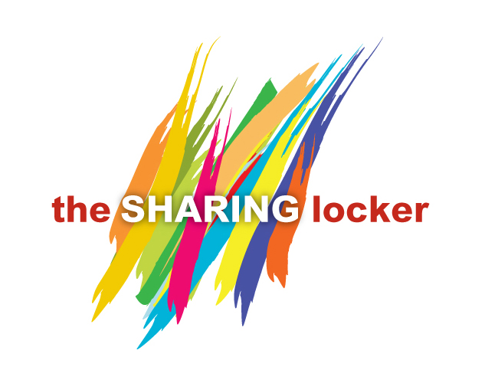
Tis the time of year when generosity takes the lead in everything we do. For Sharing Locker that means providing gifts for all of our clients, and their children, during our December 21st opening. Is there some way you can help? INDEED THERE IS!!! Simply purchase any of the items below and bring them to church, placing them in the sparkly red box in Smith Hall. If your time is limited and you can’t shop, a donation of cash or check would be greatly appreciated. Our Elves will shop for you. Below are some suggestions.
NEW OR VERY GENTLY USED GIFTS, SUCH AS:
For Infants: Baby outfits
For Children: Games and toys; children’s slippers, clothing (jackets, sweaters, sweatshirts/pants, pjs
For Adults: Gift Boxed Toiletries
Gift sets of mugs with teas/cocoa
Household items: vases, picture frames, coasters, candles
Adult games and puzzles
Clothing: jackets, sweatshirts, sweaters, slippers
Wallets, handbags or shoulder bags
WHAT?? YOU’VE NEVER VOLUNTEERED FOR SHARING LOCKER? Don’t wait any longer. Our December 21st Sharing Locker is particularly busy with all the Holiday festivities and gifts. When the eblast goes out the week before, don’t hesitate to sign up. You’ll marvel at how easy it is and how GREAT you feel at the end of the morning. The shift is 10 am to 12 noon. If you can stay a few minutes later to help put everything away in anticipation of church school, that would be great.

