BIO - Reverend Amy Beltaine
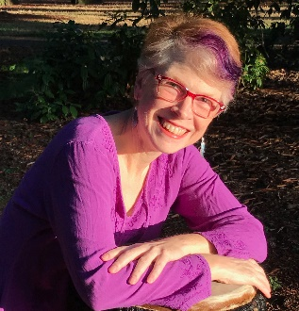
Reverend Amy Beltaine provides a UU ministry of spiritual mentoring through individual and group appointments, Sunday services, rites, and rituals. Helping friends and family of the oppressed to break open instead of being broken by the pain in the world. You crave a world of love and justice: Revive your spiritual verve! When (spouse) Hawthorne and Amy are not pulling their little home behind them they are at home in Portugal or in Portland, Oregon. A graduate of Meadville Lombard School for the Ministry, Amy is on the coordinating committee of the UU Spiritual Directors’ Network. Amy is an accredited Spiritual Director and supervisor, nearly life-long earth-honoring Process Pan-en-theist, and faculty member at Cherry Hill Seminary. Amy aspires to become a Love-Ninja. (Connect with Amy at http://amybeltaine.info. OR Reverend Amy is offering a “spiritual type assessment”. Go to her website at http://amybeltaine.info to take the quiz and to explore your spiritual direction.)

