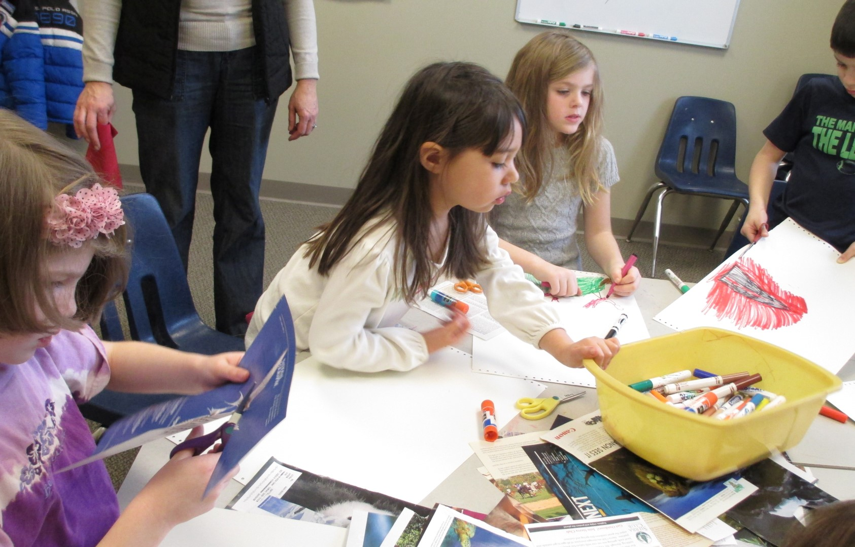  OUR UNITARIAN PRINCIPLES  The rainbow, and its acronym ROYGBIV, is used in our program to guide children by sharing Unitarian Universalist Principles in their most simple form:  Respect the importance of all beings.  Offer fair and kind treatment to all.  Yearn to learn throughout life.  Grow by exploring ideas and values together.  Believe in our ideas and act on them.  Insist on peace, freedom and justice for all.  Value our interdependence with nature.  For more information on Unitarian Universalism we encourage you to speak to our minister or a member of the YREC committee, or visit http://www.uua.org/beliefs |  |  |  |  | Contact Us  Westminster Unitarian Church  Phone: 401-884-5933  Email: info@westminsteruu.org  Web: http://westminsteruu.org/  Minister – Rev. Ellen Quaadgras  Religious Education Coordinator  Katie Lally (klally@westminsteruu.org)  Youth Religious Education Committee  The chair for 2016 -2017 is Carla Swanson Carlaswanson325@gmail.com  Other Committee members are Melanie Lally, Linda Hevenor, April Cambre, and Nancy Reed.  New members are welcome!  Westminster Unitarian Church  119 Kenyon Avenue  East Greenwich, RI 02818  Over 75 children and youth participate in our Youth Education program. All children must register in order to attend, but there is no fee for classes. The program is supported by the annual pledges of WUU Church members and friends. |  |  |  |  |  | Westminster Unitarian Church  - Religious Education for Children and Youth 2016-2017  The goal of youth religious education at Westminster is to provide a loving, safe and nurturing community in which our children and youth can develop their own beliefs and embark on their own spiritual journey. We believe that the search for truth is lifelong, and we seek to support children and families in their faith development.
Welcome to  Youth Religious Education at Westminster Unitarian Church.  We’re glad you’re here!  Our program includes worship, Sunday morning classes, theme-based multi-generational activities, service opportunities, and more.  2016-2017  Sunday Morning Programming  Childcare (9:00am-10:00am) - 6 mo to 4 yr  Classes (9:00am-10:15am)  Grades K/1/2 – Ideas about God plus Spirit Play and Spirit of Adventure  Grades 3/4 – Ideas about God plus Spirit Play, Our Whole Lives (OWL) grades 4 & 5, and Spirit of Adventure  Grades 5/6 – Neighboring Faiths - An experiential comparative religions class, which includes group learning and visits to a variety of faith communities, plus Our Whole Lives (OWL) - grades 4 & 5 - and The Gospel according to The Simpsons (grade 6)  Grades 7/8 – Compass Points, plus The Gospel according to The Simpsons (w/grade 6) |  |  |  |  |  | Senior High School Youth Group (SYG) meets on alternate Sundays. Activities include field trips, service projects, youth worship and district-wide Senior High Youth Group Conferences (CONs).  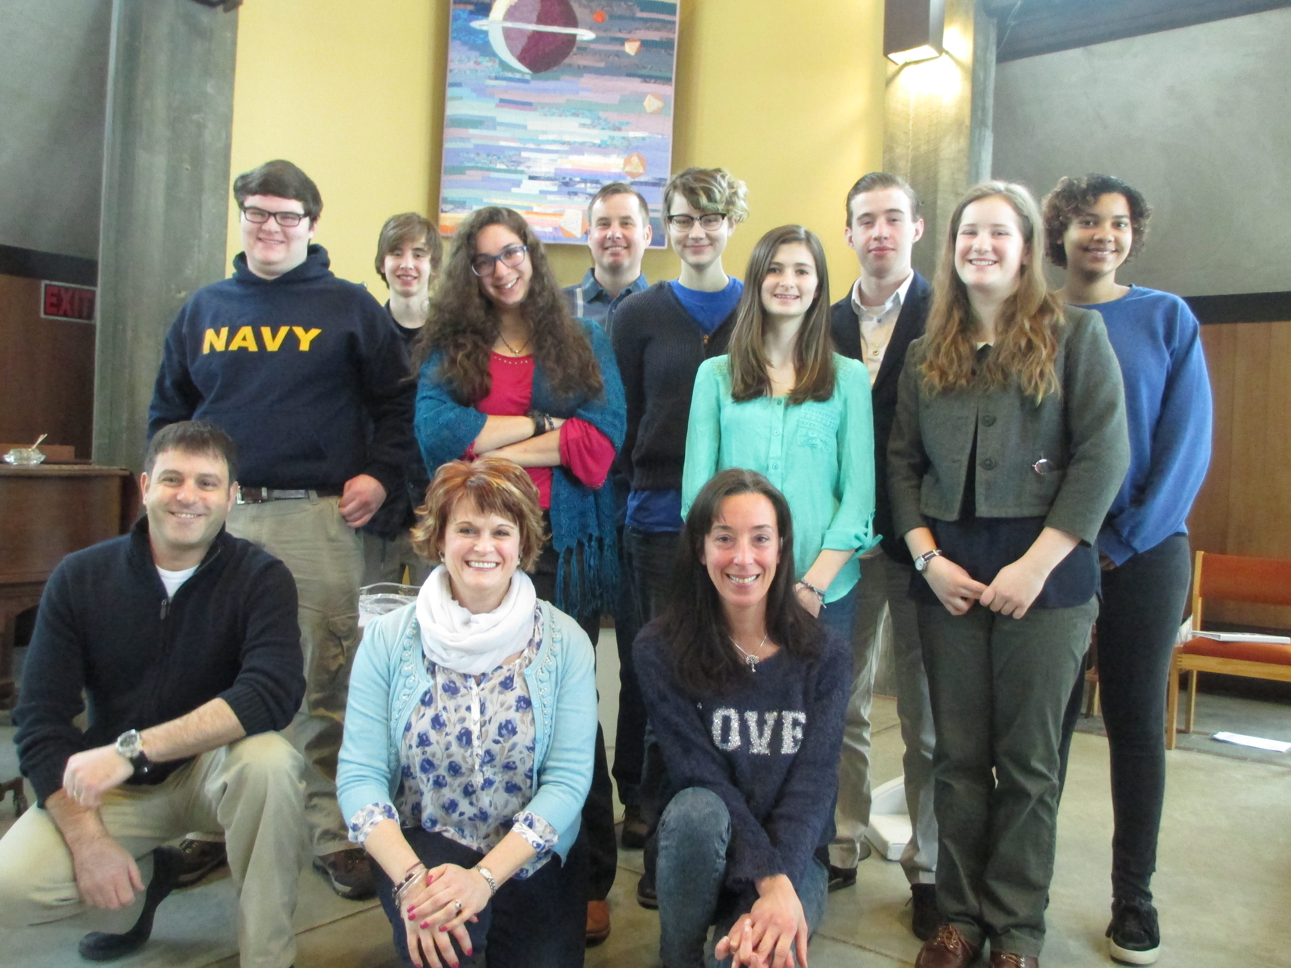  Other Opportunities for  Children and Youth  Multi-Generational Worship Services, Events and Activities: Held periodically, there are opportunities for the entire congregation – children, youth, and adults of all ages – to come together in community.  Social Events: including fall kick-off party, Christmas and Easter activities, Mystery Friends, the end-of-year “RE Sundae” event and other social gatherings.  December Holiday Pageant: On the Sunday before Christmas, the multi-generational worship service features a dramatic presentation by children and youth.  Service projects: Children and youth are encouraged to participate in all-ages service work (such as the Sharing Locker), as well as youth oriented projects. |  |  |  |  | 2016-2017 Westminster Youth Religious Education (YRE) Calendar (as of 8/30/2016)  Regular classes are 9:00am-10:15am – SYG 10:30am-12:00pm  Sept. 11 Water Communion Service - YRE Kickoff Party + YRE Registration  Teacher Orientation 10:15  Term 1 Sept. 18 Regular Classes YRE Registration,  Senior Youth Group (SYG)  Sept. 22, YRE Committee (YREC) meeting, 6:30-8:00pm  Sept. 25 Regular Classes YRE Registration  Oct. 2 Regular Classes SYG  Oct. 9 Regular Classes  Oct. 16 Regular Classes SYG  Oct. 23 Regular Classes  Oct. 27, YREC Meeting, 6:30-8:00pm  Oct. 30 Regular Classes  Nov. 6 Regular Classes SYG  Term 2 Nov. 13 Regular Classes  Nov. 17, YREC Meeting, 6:30-8:00pm  Nov. 20 Regular Classes SYG  Nov. 27 K-8 Combined Class  Dec. 4 Regular Classes SYG  Dec 11 Regular Classes  Dec. 15, YREC Meeting, 6:30-8:00pm  Dec. 18 Multigen Christmas Service  Dec. 25 No RE (Christmas Day)  Jan. 1 No RE (New Year’s Day)  Jan. 8 Regular Classes  Jan. 15 Regular Classes SYG  Jan. 22 Regular Classes  Jan. 29 Regular Classes  Term 3 Feb. 5 Regular Classes SYG  Feb. 12 Regular Classes  Feb. 19 K-8 Combined Class (Feb break) SYG Feb. 26 Regular Classes  Mar. 5 Regular Classes (Mystery Friends) SYG Mar. 12 Regular Classes  Mar. 19 Regular Classes SYG  Mar. 26 Regular Classes (Mystery Friends ends)  Apr. 2 Regular Classes SYG  Term 4 Apr. 9 Regular Classes  Apr. 16 Easter Service - Time for All Ages  Apr. 23 Regular Classes  Apr. 30 Regular Classes  May 7 Regular Classes SYG  May 14 Regular Classes  May 21 Regular Classes SYG  May 28 K-8 Combined Class  June 4 Regular Classes SYG  June 11 Time for all ages – last day party

